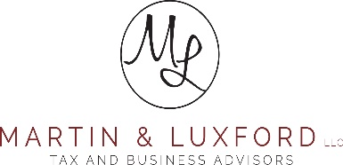

2024 Tax Season
Another year is in the books (pun intended), and we are preparing for another tax season!
What’s New:
- Not new, but 2nd year! Secure Document Upload platform SafeSend Exchange is a hassle-free way to securely upload documents to us. There are no passwords to remember! The link is on our website https://www.martinluxford.com on the “Secure Document Upload” page and under each of our names in our email messages. Please wait to upload your documents until you feel that you have everything gathered.
- There are other ways to get us your information. You can still drop off and mail in your documents!
- Tax Return Delivery. For some of you, we are using the electronic delivery system again this year. Please let us know if you received it electronically last year and would prefer to receive a paper copy this year. You can email Nicole at Nvandyke@mltax.net to make that change.
- New Team members!
Please join us in welcoming Meg & Nicole. Nicole and Meg are our new Office managers. Please also join us in welcoming Amanda. Amanda is our new staff accountant.
- Retiring
We are sad but happy for Janel. She has retired and will be greatly missed. Meg and Nicole are your go-to people if you are wondering who to contact now. Between the two of them, we have you covered!
- Like us on Facebook. This is a great way to get updates as the tax codes change. Also, we are pretty funny for accountants, so we will share good Jokes too

You can leave a Google review for us! Use the QR Code below
